**Project Design Phase**

**Problem – Solution Fit Template**

|  |  |
| --- | --- |
| Date | 25 june 2025 |
| Team ID | LTVIP2025TMID45798 |
| Project Name | Smart Sorting: Transfer Learning for Identifying Rotten Fruits and Vegetables |
| Maximum Marks | 2 Marks |

**Problem – Solution Fit Template:**

It ensures that you have identified a real problem your users face and that NutriGaze is designed to effectively solve it. It validates the need for your AI-powered freshness detection system and aligns it with user needs to drive adoption.

**Purpose:**

• Solve complex problems: Help consumers, vendors, and farmers detect rotten fruits/vegetables using AI.

• Faster adoption: Leverage the common behavior of taking photos and using smartphones to detect freshness.

• Sharp communication: Use clear messaging – “Check your produce freshness instantly with NutriGaze.”

• Increase touch-points: Provide a trustable solution for users to avoid consuming or selling rotten produce.

• Improve target group’s situation: Empower users to prevent food waste and ensure food safety with quick detection.

**Template:**

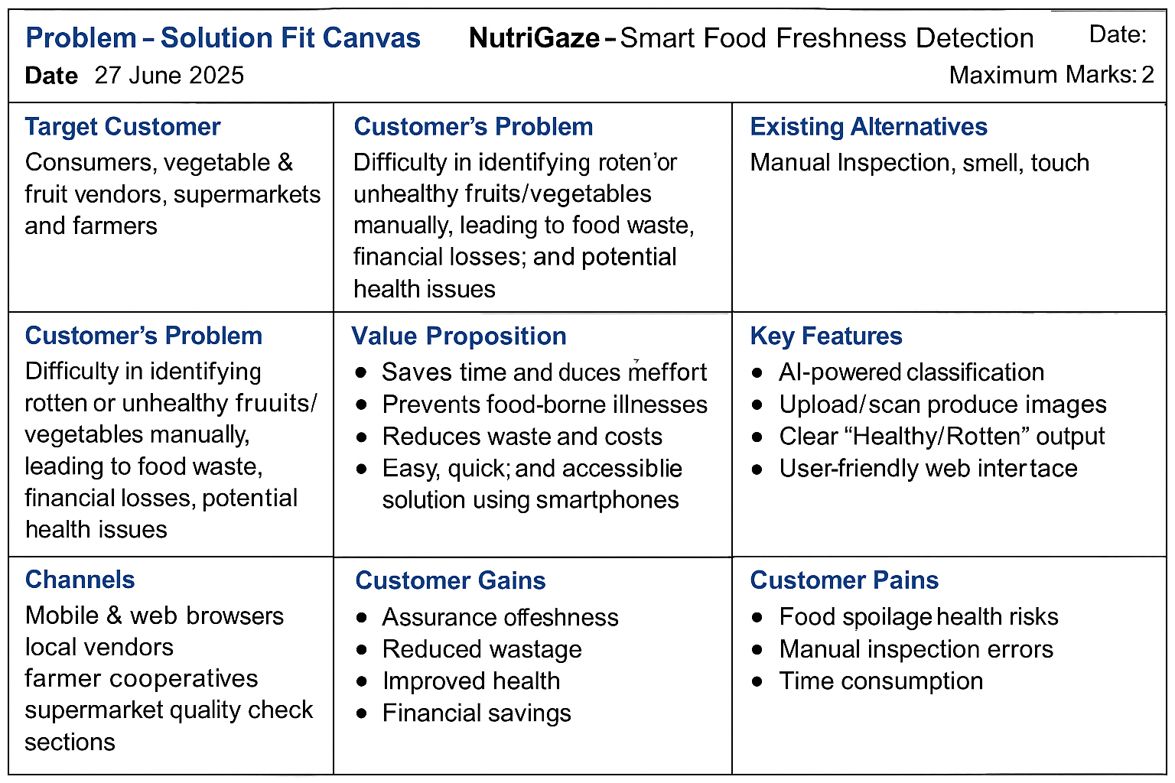

**References:**

* [**Problem-Solution Fit Canvas – Idea Hackers**](https://www.ideahackers.network/problem-solution-fit-canvas/)
* [**Epicantus on Problem-Solution Fit Canvas**](https://medium.com/@epicantus/problem-solution-fit-canvas-aa3dd59cb4fe)